**“Spatial Data Focusing and Physical Layer Security”**

**Keywords**: Wireless Communications, Propagation Channel Model, MIMO systems

A master internship position is offered at Sorbonne University (SU), in Paris, to work in the French-ANR-funded GEOHYPE project, in collaboration with the Wireless Communications Group from ULB.

**About the context of the project**

The goal of the GEOHYPE project is to investigate physical solutions that enable the broadcasting of information to specific spatial locations, using limited infrastructures. From a scientific point of view, the problem is to find a way for a base station to wirelessly transmit data that are decodable only within desired areas. To do so, an approach combining signal processing and Multiple-Input Multiple-Output (MIMO) systems is undertaken in order to overcome the limitations of classical beamforming techniques. The idea is for an antenna array to exhibit hyper resolution spatial data focusing.

Two approaches have been investigated so far:

* **Location-based** data broadcasting
* **People-based** secure communication

The first approach, known as **Spatial Data Focusing (SDF)**, ensures that the transmitted data can be decoded only within a given area, and any user passing by this area is able to retrieve the data, without the need for GPS positioning. This is useful in smart cities for instance where location-based data needs to be broadcast (e.g., for tourism, danger alert for visually-impaired persons…).

The second approach, known as **Physical Layer Security (PLS)**, ensures that the transmitted data can be decoded only at a particular user location, by exploiting the unique properties of the propagation channel between a base station and a particular user in the data precoding. This avoids the need to exchange secret keys for securing communications like in classical cryptography.

In both cases, the goal is to transmit data that can be decoded within a specific area thanks to dedicated precoding, based on either a multiple-antenna architecture (currently under investigation by G. Molineaux and M. Odhiambo, both joint ULB/SU PhD researchers) or based on time-reversal (currently under investigation by S. Golstein, joint ULB/SU PhD researcher).

**About the internship work**

The goal of the internship is to work within the GEOHYPE project together with the team. Several investigations are currently on-going which range from signal processing to wave propagation, and also include experimental aspects. The exact tasks of the internship can be determined after discussion with the internee and may be chosen from:

* Assess the performance of GEOHYPE techniques within a 5G context using the last 3GPPP releases (influence of the flexible numerology, carrier aggregation, etc.)
* Multiuser aspects:
  1. In SDF geocasting: how to share resources to address different locations?
  2. In PLS: how to use other user data as artificial noise to secure a communication?
* Channel-based machine learning precoding for security
* Propagation channel assessment for security evaluation in different environments
* Experimental implementation of GEOHYPE algorithms (using USRP-based MIMO bench)

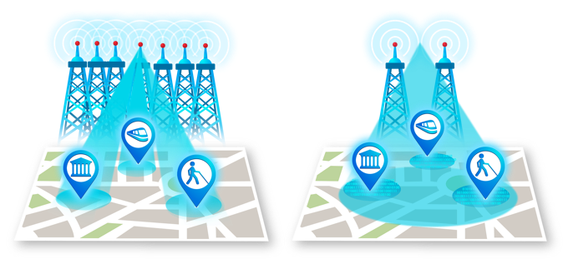

Figure 1 - Traditional beamforming (left) and Spatial Data Focusing (right)

**About the environment**

The candidate will benefit from a favorable environment as this work is part of the GEOHYPE project, funded by the French ministry of research (ANR). The project is in collaboration with the ULB university in Brussels, Belgium (Prof. François Horlin and Prof. Philippe De Doncker). Frequent interactions with PhD researchers are considered to coordinate the work. Based on candidate personal interest, a master thesis at ULB/VUB can be organized in the continuity of this internship and a PhD program can be proposed accordingly.

Sorbonne University (first ranked university in France), is located in the center of Paris, and offers an attractive working environment for students from all over the world (<https://www.sorbonne-universite.fr/en>).

A scholarship of about 600€ per month will be provided (it is also possible to obtain an additional Erasmus grant from VUB/ULB, to cover living costs).

*In case of lock-down due to the current COVID situation, an alternative back-up plan can be organized at ULB/VUB if necessary and the work coordinated online from Paris.*

**Qualification and requirements:**

The candidate should be highly motivated, autonomous, and fluent in English or French. She/he should be enrolled in a master program in Telecommunication Engineering, Electrical or Electronic Engineering, Physics or an equivalent degree with a strong mathematical background.